**Lost in Transit: The PalletSense Challenge**

**Background**

PalletSense, a leading provider of smart pallets embedded with IoT chips, is revolutionizing the logistics industry. These smart pallets transmit crucial data, including location, timestamp, and temperature, helping businesses streamline their supply chain operations. Operating across the U.S., PalletSense primarily serves the retail sector, ensuring smooth upstream and downstream movement of goods between warehouses, distribution centers, and stores.

To see PalletSense in action, let's look at how it collaborates with one of its key customers, **Customer-A.** This customer relies on smart pallets for both **upstream** (supplier to warehouse) and **downstream** (warehouse to store) operations.

(Refer to the diagram below for a visual representation of the process.)

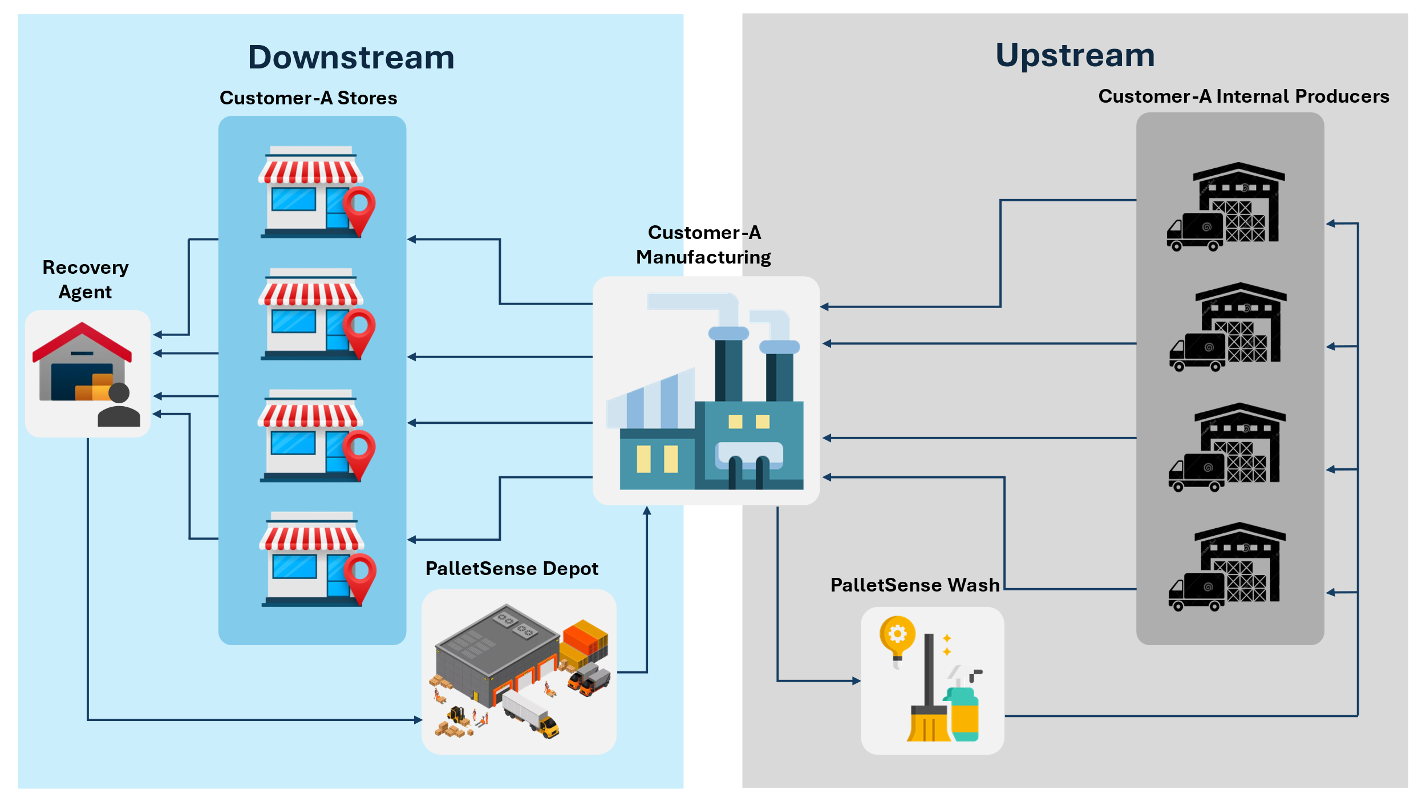

Every day, pallets travel across the country, ensuring delivery of goods. Pallets, loaded with goods, are transported in vehicles between warehouses, stores, and demand centers—typically moving in groups. Once deployed to customers, these smart pallets intermittently transmit location data at random intervals. However, there is a critical challenge in this system—infrequent location updates.

**The Problem**

Each smart pallet is equipped with a GPS sensor, but GPS is notoriously power-hungry. To conserve battery life, PalletSense limits the GPS ping rate to only 2-3 times per day per pallet. This low frequency creates a visibility gap—for a journey spanning 3-6 days, a pallet remains off the radar for long stretches, making it nearly untraceable and impossible to track in real time.

This gap leads to several operational and financial challenges:

1. Lost Pallets – Pallets that veer off-route can remain undetected for days, sometimes resulting in permanent loss.
2. Delayed Interventions – Without sufficient and timely updates, it becomes difficult to proactively intervene when a pallet goes off-course.
3. Billing Issues – If a pallet stays at a customer’s location for too long, it becomes difficult for the pallet company to get it billed from their customers, leading to revenue losses.
4. Underutilization – Each smart pallet costs $150, and if lost or underutilized, it directly affects the company's bottom line.

**The Challenge**

PalletSense is looking for an innovative approach to improve tracking without increasing the GPS ping frequency. Your mission is to use the limited available data and develop an approach that:  
✅ Enhances visibility into pallet journeys using analytical techniques to ensure more regular updates on locations of its pallets.  
✅ Detects deviations and generates alerts for off-route scenarios to allow adoption of pro-active intervention measures.

In the first stage of development, by devising and implementing a solution, PalletSense aims to achieve the following key objectives:

1. Ability to track all pallets on-route with greater regularity and reliability.
2. While ensuring regular updates on pallets whereabouts, identify how a deviation can be conclusively established so that alerts can be triggered.

**Dataset**

To tackle this, PalletSense is providing two datasets:

1. **Known Route Repository** – A collection of commonly travelled routes based on historical data, including known locations.

(Note: Known locations are those points where either PalletSense has its depot or it is a customer’s warehouse, depot, store etc. You will find the GPS location for known locations in the known-route repository data. The first and last location/ row of every unique route represent the known locations to PalletSense)

Data Description:

Route_ID: Unique identifier for the route

Timestamp: Time at which location was pinged

Latitude: Latitude of the pinged location

Longitude: Longitude of the pinged location

1. **Ongoing Trip Data** – Real-time GPS pings from pallets currently in transit.

This is a snippet of real-time data that the company collects of ongoing pallet trips. This data has pallet GPS pings received over a course of x days encompassing varied trips completed by the pallets. **Assuming that the data is flowing in real-time**, devise and implement an approach using the data to solve the problem.

Data Description:

Pallet ID: Unique identifier of pallet

Timestamp: Timestamp at which ping was recorded

Latitude: Latitude of the ping

Longitude: Longitude of the ping

**Please explain the approach you designed to address the pain-point for ongoing trips in detail.**

**Key Questions to address in your explanation:**

* Are any pallets traveling together?
* Which known routes were the pallets following? How can we determine route adherence?
* Did any pallets deviate from their known routes? Is it possible to measure whether a pallet is on-route or off-route?

**Additional Question – Detecting Stationary Pallets:**

Without implementing the solution, outline an approach to detect and raise alerts when pallets remain stationary at known customer locations (e.g., depots or demand centres) for an extended period. How can historical data and ongoing trip data be leveraged to identify pallets that are stuck at a location? Make reasonable assumptions where needed.

**Instructions:**

Your task is to design and implement an analytical approach to address the challenges posed in ongoing pallet trips. You are **not** required to build a real-time tracking system for demonstration but rather to devise and implement a methodology to solve the underlying problem using the provided data.

The case should cover the following area with project code/ workflow, PDF document and short PPT for final presentation.

|  |  |
| --- | --- |
| Sr. No | Method |
| 1 | Identification of Business Problem |
| 2 | Data Preparation and Availability |
| 3 | Proposed Approach |
| 4 | Analysis |
| 5 | Conclusion and Findings |

Can you bridge the data gap and ensure that pallets are regularly tracked while in transit? The future of smart logistics depends on your solution!